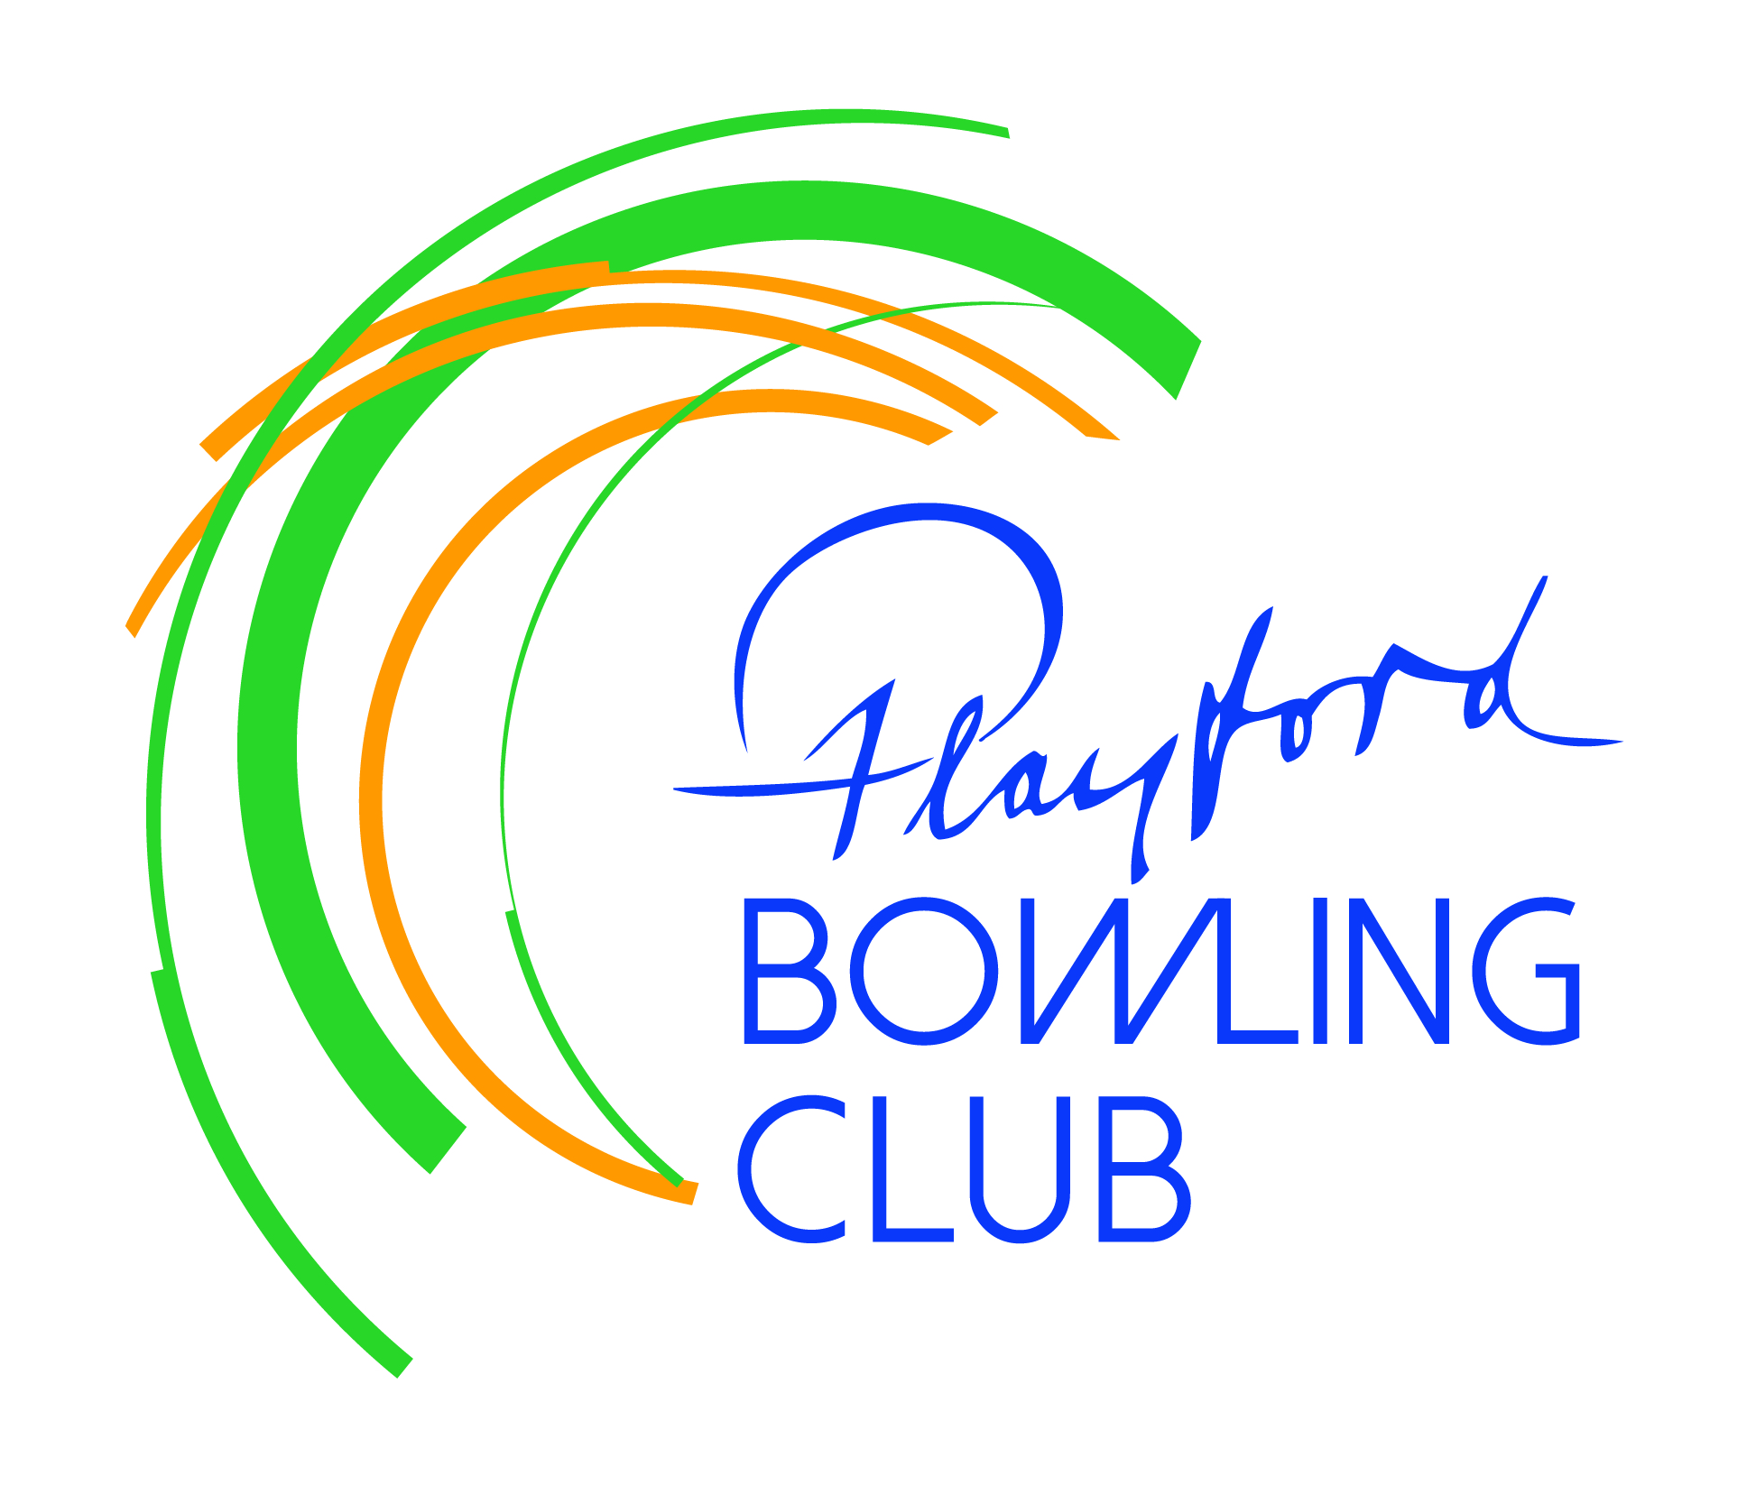Playford Bowling Club Inc.

PO Box 34 Elizabeth SA 5112

**April Newsletter**

**President’s Report**

**WOW – what a month!!** We had four pennant teams (Ladies & 3 Saturday sides) involved in finals campaigns and they all did us proud. Our Div 7 team finished third, losing their preliminary final at Two Wells, but the experience gained will be invaluable next season. Our Div 6 side finished second, losing the Grand Final to Modbury despite winning 2 of the 3 rinks. Hard luck guys & gals, but you should be very pleased after a successful season and can go one better next year.

Our Div 5 team finished champions. They had the reverse situation to the Div 6 side, winning only one rink out of four, but such was the dominance of Terry Coles’s four that one rink was enough! These bowlers had a dominant year in their division but you still have to get the job done on the day.

Hearty congratulations to all – they are now ready to test themselves in a higher division next year.

The Ladies’ team also finished champions, with a gutsy never-say-die win in their Grand Final. They trailed for most of the match, only hitting the front on the 60th (of 63) ends. *Their effort in scoring 13 vs 2 shots in the last 9 ends serves as an example to persevere no matter the outlook.* So proud of our girls, who had a difficult start to the season after the retirement of 4 of last year’s starting 12. They found form after Christmas and reached 3rd spot by the end of the season, before beating the second team away in the prelim, and the top team Modbury in the GF. Inspirational ladies!

So all in all a very successful season on the greens/blues. Many thanks to the selectors for their efforts this year – it’s not an easy job, but it’s a vital one.

Away from the greens it’s also been a big month. On March 25 we hosted the **Inter-Schools Challenge** – some of these high school students showed unbelievable form for their age. Then on the weekend of March 29/30 we hosted the **Ladies Prestige Medley Finals**, with 12 regional teams from all over SA competing over two days. It’s quite a marathon, starting at 9am Saturday and the GF finishing at 6:30pm Sunday. Fantastic bowling, played in a wonderful spirit. We thank Bowls SA for again entrusting Playford Bowling Club with the responsibility of hosting this prestigious event and Playford Council for sharing the hosting fee.

The LPMF could not have been hosted without the tremendous efforts of our team of volunteers. Ron Slager organised a working bee on the preceding Monday and with his grounds team had the greens in top shape. He and Peter Coombs turned up very early on both days to set the rinks up, and packed away afterwards. The stars of the show were our dynamic duo Sheryll and Mardi in the kitchen, who – with great support from Tanya Cassidy, Lyn Ruddock, Mari Walker and Tony Johnston - managed to provide about 140 meals on each of the two days, as well as sandwiches and cake for the spectators. Craig Eckert and Doug Kendall cooked the BBQ on the Sunday and Marian Crawford provided loads of fruit cake and cream profiteroles free of charge. Anne-Marie Eckert helped where she could despite still recovering from operations to one arm and Andy Crawford and his helpers (Andy Walker, Steve Attridge & Sue Armstrong) kept the bar running for the two very long days. Thanks to all!

Steve Attridge

**Working bee**

Many thanks to **Ron Slager** for organizing the working bee ahead of the Ladies’ Prestige Medley Finals and to *Tony Johnston* for cooking the BBQ to feed the 21 members who attended. By the time we’d finished the place looked fantastic. Apart from these fellas, thanks also to: *Sherryl & Doug Kendall, Mardi Johnston, Steve & Sue Attridge, Dave & Di Gibbard, Marg Linke, Lyn Ruddock, Gavin Wood, Peter Coombs, Andy Thompson, Dave Mercer, Roman Muzyka, Terry Coles, Brenton Ruciack, Peter deBlaauw, Trevor Matthews, Terry Bettens, Andy Crawford.*

**Some more of our sponsors…**

**Matt Burnell MP** is the **Federal Member for Spence,** which includes the City of Playford, Town of Gawler and parts of the Barossa Council, City of Salisbury, and Light Regional Council. My office and I are here to help and can assist you with a range of Federal Government matters including Veteran’s Affairs, Medicare, Centrelink, Passports, ATO, NDIS, MyAgedCare, Community Grants and Congratulatory Messages.

**Salisbury & Elizabeth Funeral Services** have been helping people through difficult times since 1984, and now with a brand new chapel facility in Elizabeth North, we are able to provide the best for the people of Playford (at no extra cost). We offer a range of services to suit you, being a family business our focus is on people, not sales. We have some of the longest serving and most experienced staff in the industry and they are available to help you.

Our support of local clubs is very important to us, as clubs serve a critical role of bringing together the local community. So if the need arises or you'd just like to have a chat and get some information - please give us a call on 8255 5607.

*SEFS will generously sponsor a Past Players Memorial Tournament on August 3rd (details later).*

**Miscellaneous**

Thanks to all those who answered the call for more helpers for the Thursday night bingo team. Craig & Ann-Marie Eckert and Steve & Sue Attridge have joined a roster with Ria DeBlaauw and Brenton Ruciack selling tickets, while Andy Thompson and Chris Turner have joined the clean-up teams, alongside Terry Bettens, Craig Keeley, Terry Coles, Tony Johnston, Doug Kendall and Dave Marsh. **Andy Crawford** is now in charge and he and Marian are on board every week.

The **Board of Management** have re-negotiated our deal with Lion-Nathan for the provision of beer. As a consequence 2 of our 5 beer lines have been freed up for the introduction of kegs from Cooper’s, who have come on board and agreed to sponsor a Charity Tournament later in the year.

**Dates for your diary…**

**April 12 –** Cocktail Night this Saturday. $10 admission – see notice board flyer.

**May 23 –** Schnitty night. Happy hour from 4:30 – 6pm, food orders taken from 5-6:30pm.

Limited places - see Marian Crawford to book.

**May 25 – AGM** starting at 2pm sharp

**June 16 –** Big Morning Tea – fundraiser for Anti-Cancer Foundation. See Marian for more info.

**July 26 –** “Back to the 70s” - live band, $10 admission. More details from Tony Johnston.